**Influence of Others 2 (Module)**

**Module: Milgram’s Experiment**

**Subtopic: Milgram’s Experiment  
-**you are designated as the Teacher and the other subject is the Learner (who is actually a confederate in the study but you are unaware)  
-the Learner is connected to chock electrodes while you as a Teacher quietly watch  
-during the setup, the Learner casually mentions that he has a heart condition which raised your concerns, but the experimenter assures him that the shocks would do no permanent damage  
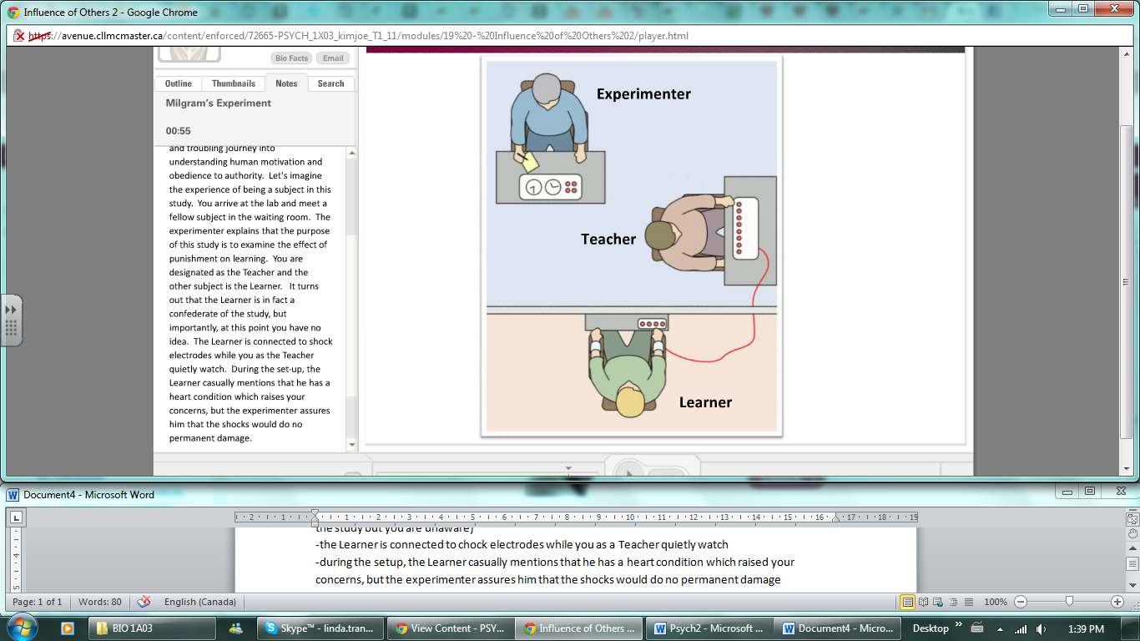  
-as the Teacher, you are taken into a different room (control room) and seated in front of a console containing a row of some very serious looking switches  
-each switch is marked with a shock voltage ranging from 15 to 450 volts; to add to the effect, some of the switches have captions such as “slight shock”, “moderate chock” and “danger, severe shock.”  
-as Teacher, you are to read a list of word pairs to the Learner, who in turn must correctly respond with the second word in the pair  
-to improve answers, the Learner will receive a shock for every incorrect answer; the shocks will progressively increase  
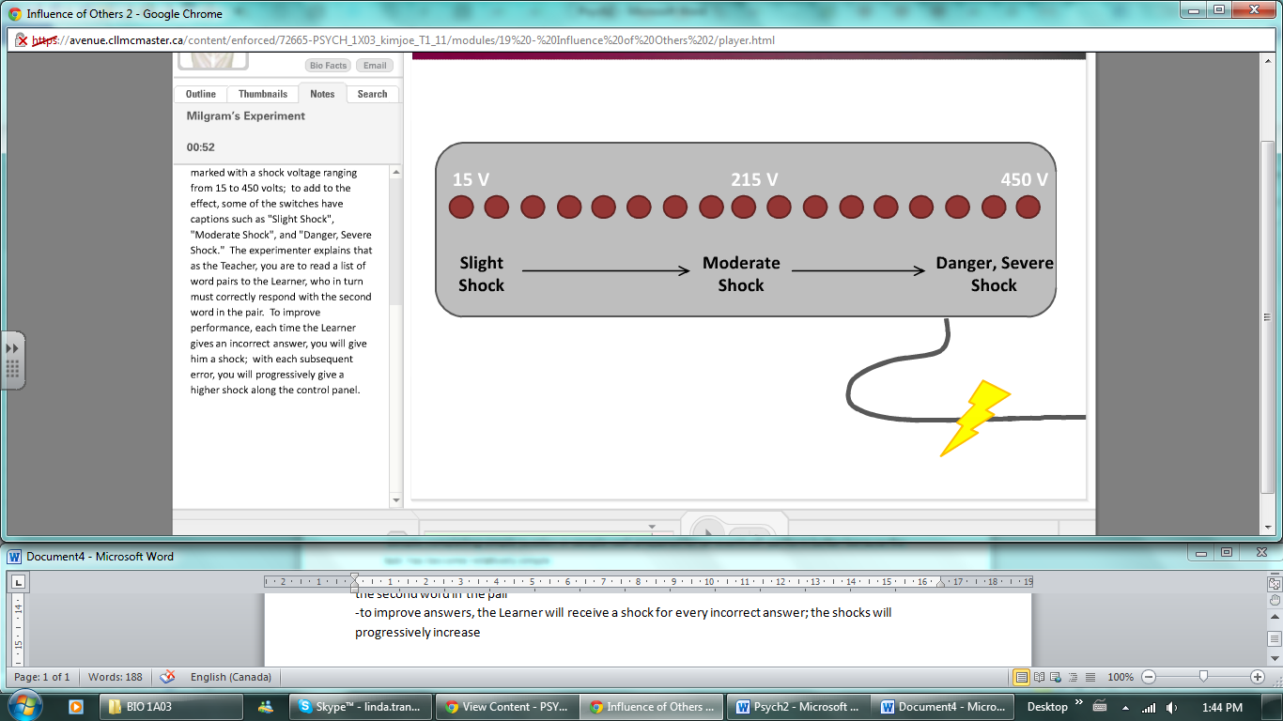 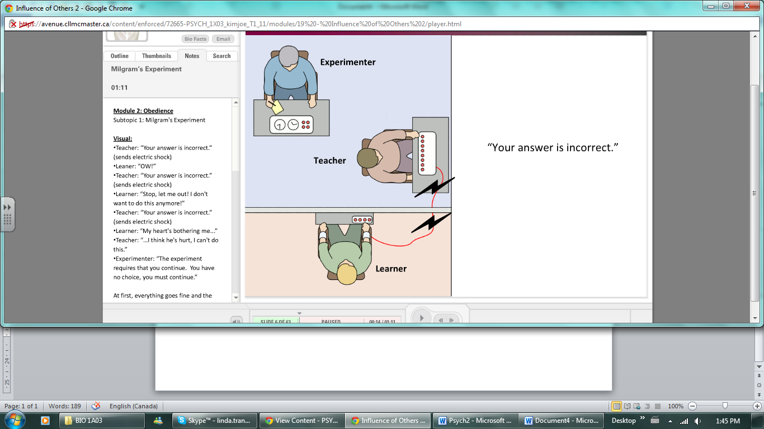   
-how long would you be able to do this? Even after hearing no response, would you be able to continue?  
-65% of all subjects continued until the very end of the experiment delivering a shock labeled “Danger, High Voltage” to a non-responsive man with a heart condition

**Subtopic: Important Lessons  
-**there is a very strong tendency of obedience to authority, even if this power is limited  
-you are not always an accurate judge of how you would behave in a given situation  
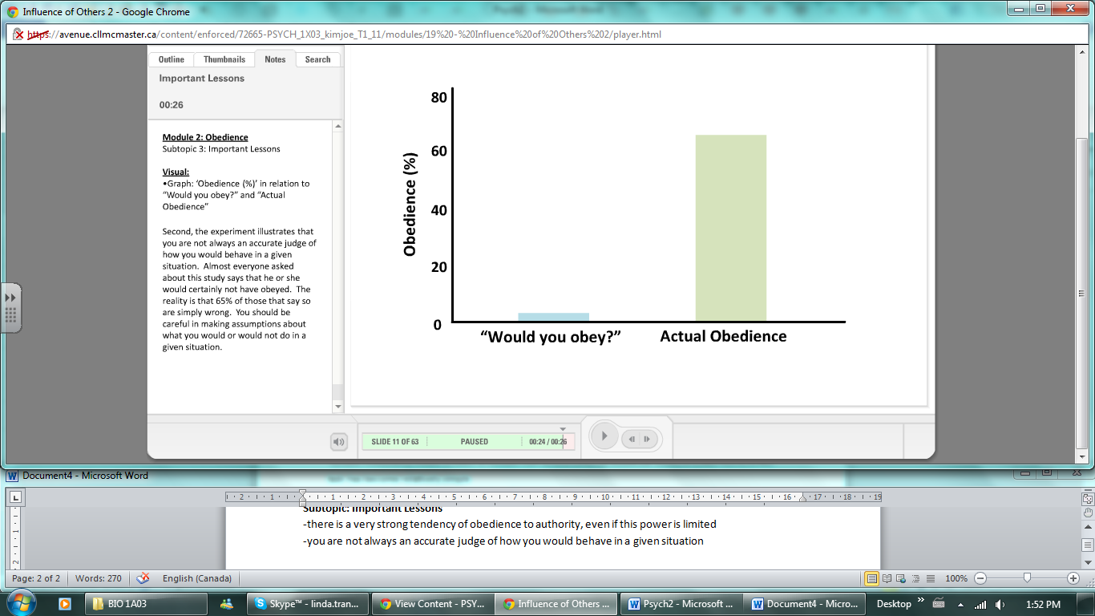   
-most subjects were emotionally devastated by the experience (ethics was a major factor)

**Subtopic: Manipulations  
-**one possible explanation for the extraordinary degree of obedience observed was the inherent prestige with following the directions of a faculty member at Yale University.  
-from an actual study room, to a rundown office, switching from professor to undergraduate student all decreased the rate of obedience  
-another thing is that subjects continued to obey because they were separated from the Learner  
-the closer in proximity that the Teacher was to the Learner, the less likely the Teacher was to continue  
-final factor influencing obedience was proximity of the Experimenter to the Teacher  
-if ordered by phone, only 25% of subjects obeyed, in fact, a number of Teachers “cheated” by delivering shocks of lower intensity than required  
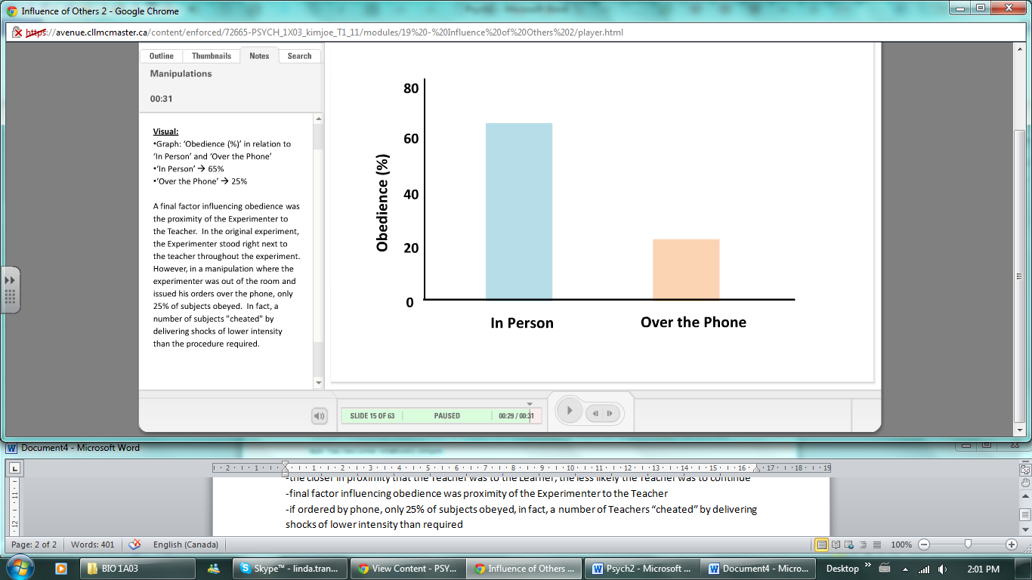

**Subtopic: Obedience in the Real World  
-**Milgram’s experiment demonstrated obedience in a lab settings, how does this apply to real life situations?  
-Hofling + colleague: man posing as doctor calls a real nurse and states that he is on his way to the hospital to asses a patient and instructs her to administer a high dosage of a fake drug to the patient (confederate)  
-however, she would be breaking several rules  
-the man is a complete stranger, the dosage is more than instructed the max is on the bottle, the drug is not on the official list of medications and medication orders should never be taken over the phone  
-nurses said that they would never obey these orders but 21 out of 22 did  
-*First*, your tendency to obey can be irresistible under a variety of circumstances  
-*Second*, you can never quite know how you would act until you are placed in a given situation  
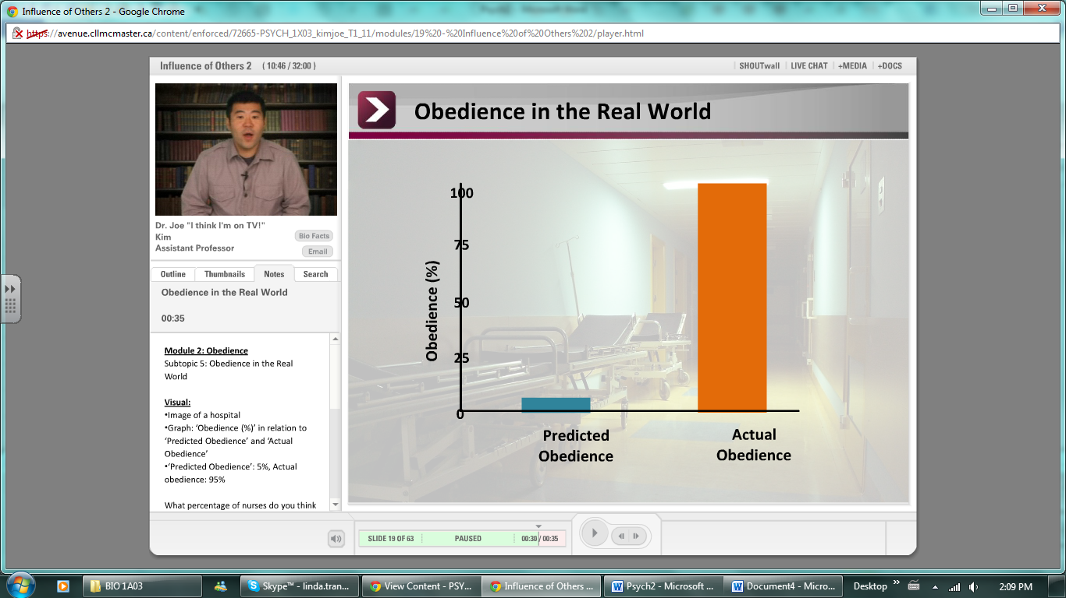

**Module: Cognitive Dissonance**

**Subtopic: Attitudes and Behaviour  
-**when you conform to a group, obey a command, or follow a social convention; you are performing a behaviour that is not necessarily in the line with your attitudes  
-can your chosen behaviour effect your attitudes? This is called cognitive dissonance

**Subtopic: Cognitive Dissonance  
-**you are asked to participate in an experiment that was stated to be exciting but you leave extremely bored  
-you are then told to talk to the next participant and tell them how exciting it was and you are either given $1 or $20 to lie to the next person; you are then asked to fill out a questionnaire about how you really felt about the experiment  
-reason why the $1 group rated the experiment higher in enjoyment is due to C.D  
-each subject subconsciously asks themselves “why did I tell the next subject that this experiment was exciting?” because they actually believes the experiment to be boring, but told the subject that it was fun, there is an inconsistency between their attitudes and behaviour   
-this inconsistency produces an uncomfortable feeling called dissonance  
-to reduce feelings of dissonance, there is an adjustment in attitude to be in line with active behaviour  
-and so, the subjects change their attitudes to match their behaviour and decide to themselves that the experiment was more interesting than they initially thought  
-subjects paid $1 will rate the experiment much higher than the ones paid $20  
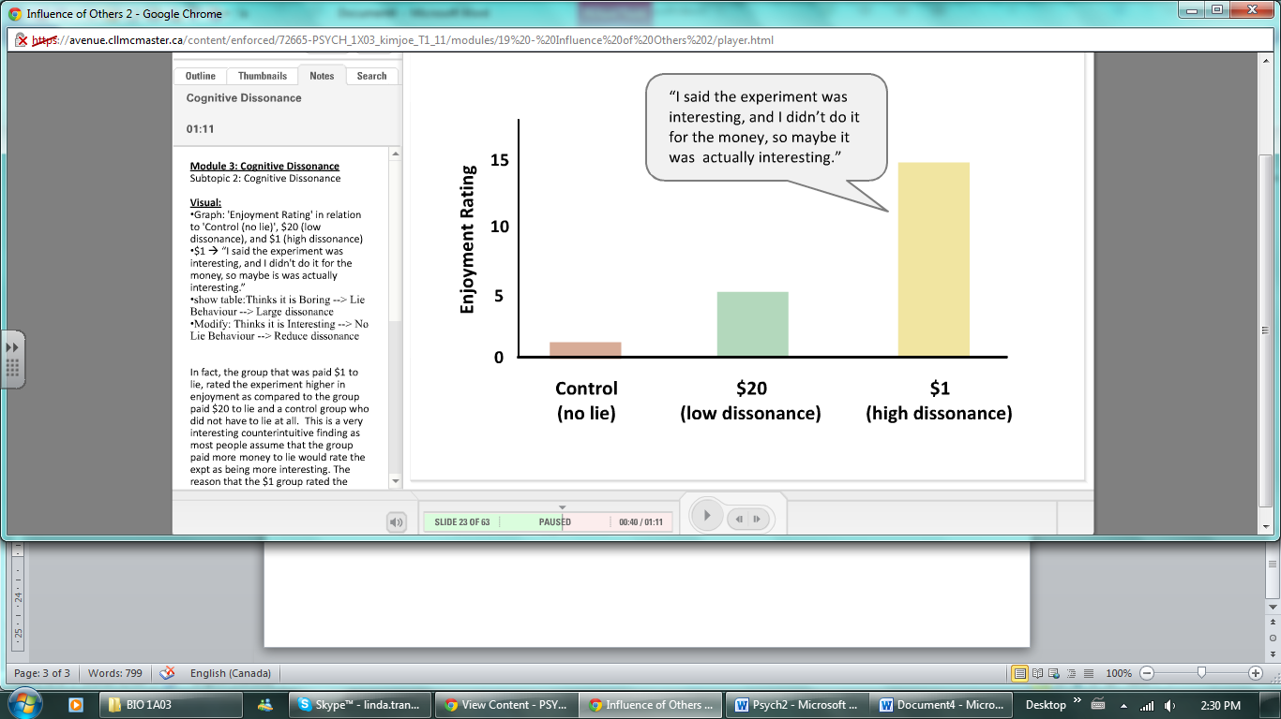 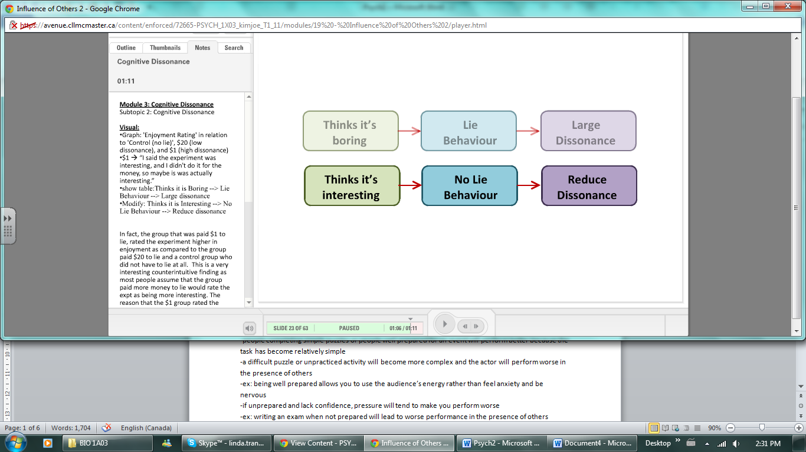

-when $20 asked themselves why they lied to next group, they say they did it for the money, feeling no dissonance because there is no conflict between attitudes and behaviour  
-their attitude is intace and they can go on believing that the experiment was boring and their inconsistent behaviour is explained by the motivation of the large $20 reward  
-for *cognitive dissonance* to take place, there must be insufficient justification for a behaviour in conflict with the attitude  
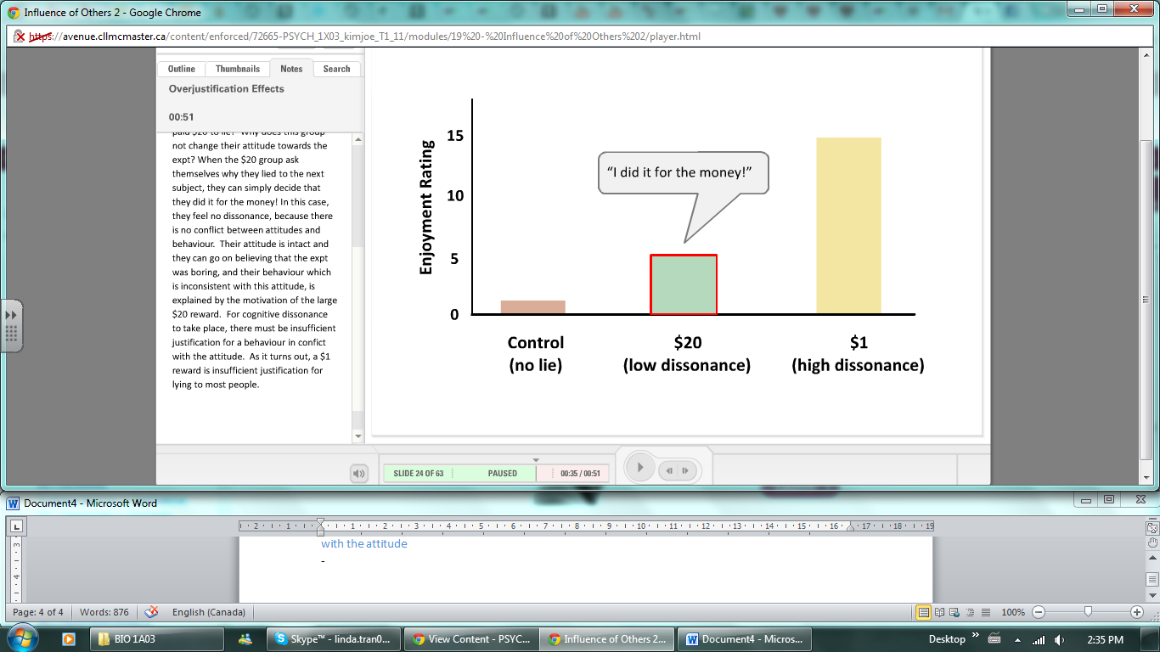

**Subtopic: Overjustification Effects  
-**if overjustify behaviour with outside motivation (money) attitude change is less likely to take place  
-instead, somehow convincing that chores are part of a group activity and that it is actually fun will lead to dissonance between original attitude towards chores and the active behaviour of washing the dishes  
-may ultimately lead to changing attitude to be in line with his new behaviour

**Module: The Stanford Prison Experiment**

**Subtopic: Zimbardo’s Prison  
-**to study the behaviour of normal people under situations of authority  
-24 subjects were chosen and passed the checks for: criminal background, psychopathology screen, anti-social behaviour screen  
-each signed and agreed to the minited diet; thise assigned to be prisoners were told to be ready for Sunday afternoon and that some of their normal civil liberties would be suspended for the length of the experiment  
-with cooperation from the police, ‘prisoners’ were mock-arrested, fingerprinted, photographed, given uniforms and were driven to the mock prison in the company of one of the mock guards  
-Guards were told to ‘maintain the reasonable degree of order in he prison necessary for its effective functioning’

**Subtopic: The Aftermath**-study expected to last for 2 weeks but halted after 6 days due to the sadistic behaviour of the guards  
-five prisoners suffered from extreme depression, crying, rage and acute anxiety (began as early as 2nd day of experiment)  
-most prisoners were willing to forfeit pay for the ability to leave the study early  
-guards never failed to show up for their ‘shifts’ and most of them voluntarily stayed late without pay  
-displayed ‘dehumanizing’ behaviour  
-referred to prisoners as numbers, forcd them to wear face coverings, made them get up in the middle of the night to parade naked  
-some were tough but fair, some went far beyong roles to engage in cruelty and harrassment, while a few were passive and rarely instigated any coercive control over the prisoners

**Subtopic: Controversial Results  
-**experiment demonstrated the incredible power that circumstance and assigned role can have on human behaviour  
-individuls who passed the test initiallywere later reported as sadistic or patholgical

**Subtopic: Deindividuation  
-Deindividuation:** in a group situation, the loss of a sense of personal responsibility and restraint (the situation where anti-normative behaviour is released in which group members are no longer seen as individuals  
-individuals who wore coats and hoos to obscure their faces shocked confederates much longer than people wearing normal clothing  
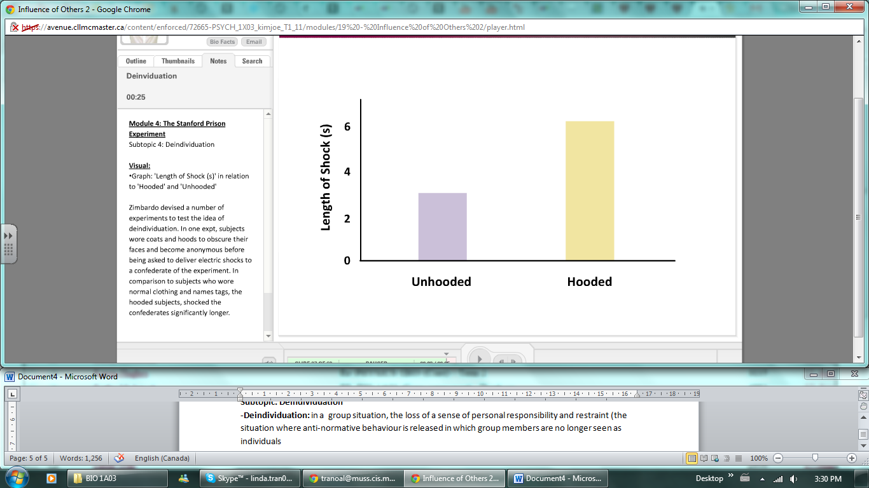  
-deindividuation can occur naturally in crowded cities

**Module: Persuasion**

**Subtopic: Persuasion**-with realizing or not, we are involved in a cycle of persuading and being persuaded by others

**Subtopic: The Communicator**-most persuasive communicator’s are those with high credibility  
-those who are perceived to be experts in a particular field are more persuasive than those who are not  
-physical attractiveness and someone to relate to (more liekly to buy from someone your age)  
-Personal Lifestyle Choices 🡪similarity  
-Matters of Objective Fact 🡪credibility  
-speech style influences perceived trustworthiness  
-speakers who talk in a very straightforward, concise manner and look their questioner in the eye are more persuasive  
-recorded messages are rated as more knowledgeable and persuasive when they are played faster

**Subtopic: The Message  
-**how you frame the messge itself  
-Audience initially agrees 🡪one-sided  
-Audience initially disagrees 🡪two-sided (acknowledge the opposing opinion, respond and then present arguments for why your position may be better)

**Subtopic: The Audience  
-Central Appeal:** well reasoned, factual, two-sidde arguments;effective for intelligent audiences  
🡪require a good thinker  
-**Peripheral Appeal:** well presented, easy to understand messages; effective for unintelligent audiences (based on easy heuristics such as attractiveness)  
🡪require a good communicator

**Module: Techniques in Persuasion**

**Subtopic: ‘Officer Scott’  
-**prank called a restaurant and identified a worker as someone who stole a customer’s purse, had her searched and gave bizarre orders but the manager complied

**Subtopic: The Foot in the Door Effect  
-The Foot in the Door Effect:** a gradual escalation of demands increases obedience  
-used language of police jargon and assumed the identity of a police officer to establish himself as a strong authority figure  
-used a gradual escalation of demands🡪first directing questions, followed by directing a search of the employee’s purse and pockets,before moving on to greater offences  
-gradual escalation works to increase an individual’s compliance  
-powerful because any one request in a series is considered in relation to the previous request and not its broader context   
-request that is seen as being less unreasonable if it follows previous requests of escalating magnitude

**Subtopic: The Low-Ball Technique  
-The Low-Ball Tehnique:** an escalation of the terms of an agreement after someone has already agreed  
-compliance is secured at a smaller cost, only to later reveal additional costs, while making the initial decision seem irreversible  
-dealer announces later on, additional charges and hidden costs, removing the advantage of the initially low price  
-LESSON! When people ask you to perform a small favour, you need to be aware of whether a larger request is likely to follow

**Subtopic: Sheep  
-**as a social being, you shape the thoughts and behaviours of others, and that they do so in return